**Animation with HTML5**

1 Download zip file “week3-files” .

Use file example_move.html as a stat point. If you click on green square it will move right and stop. Open it using Dreamweaver, to see code behind.

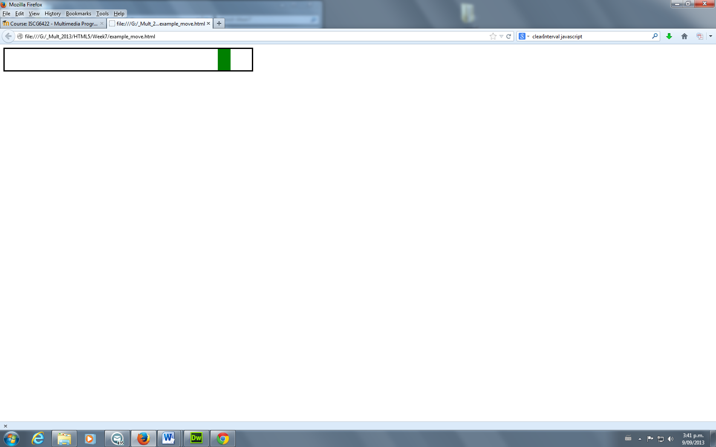

2 How to use debugger in javascript

( option 1 – use Chrome, option 2 Firefox)

In Chrome, right click/ inspect element/Source. You need to put break points and you can add Watch expresions. As all debuggger have it has **step over(F10)**, **step in(F11)**, **step out(Shift+F11)**,. Please test it how it is work.

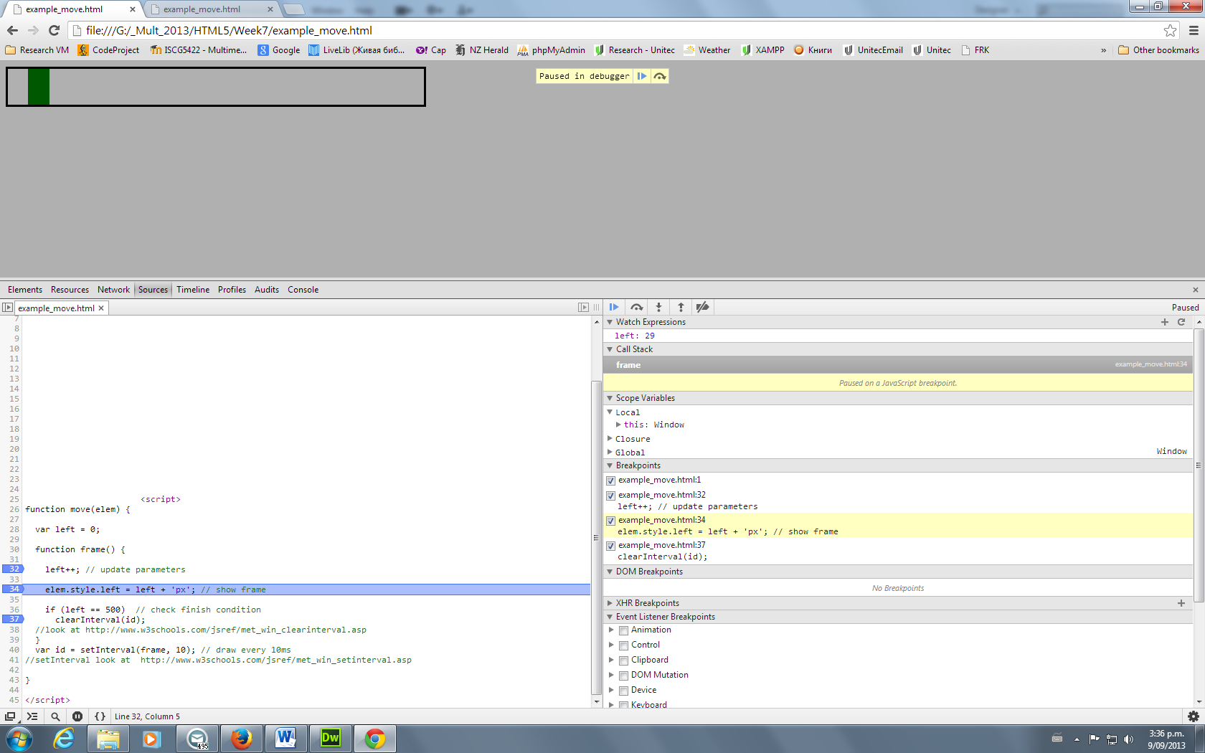

Option 2 Firefox:

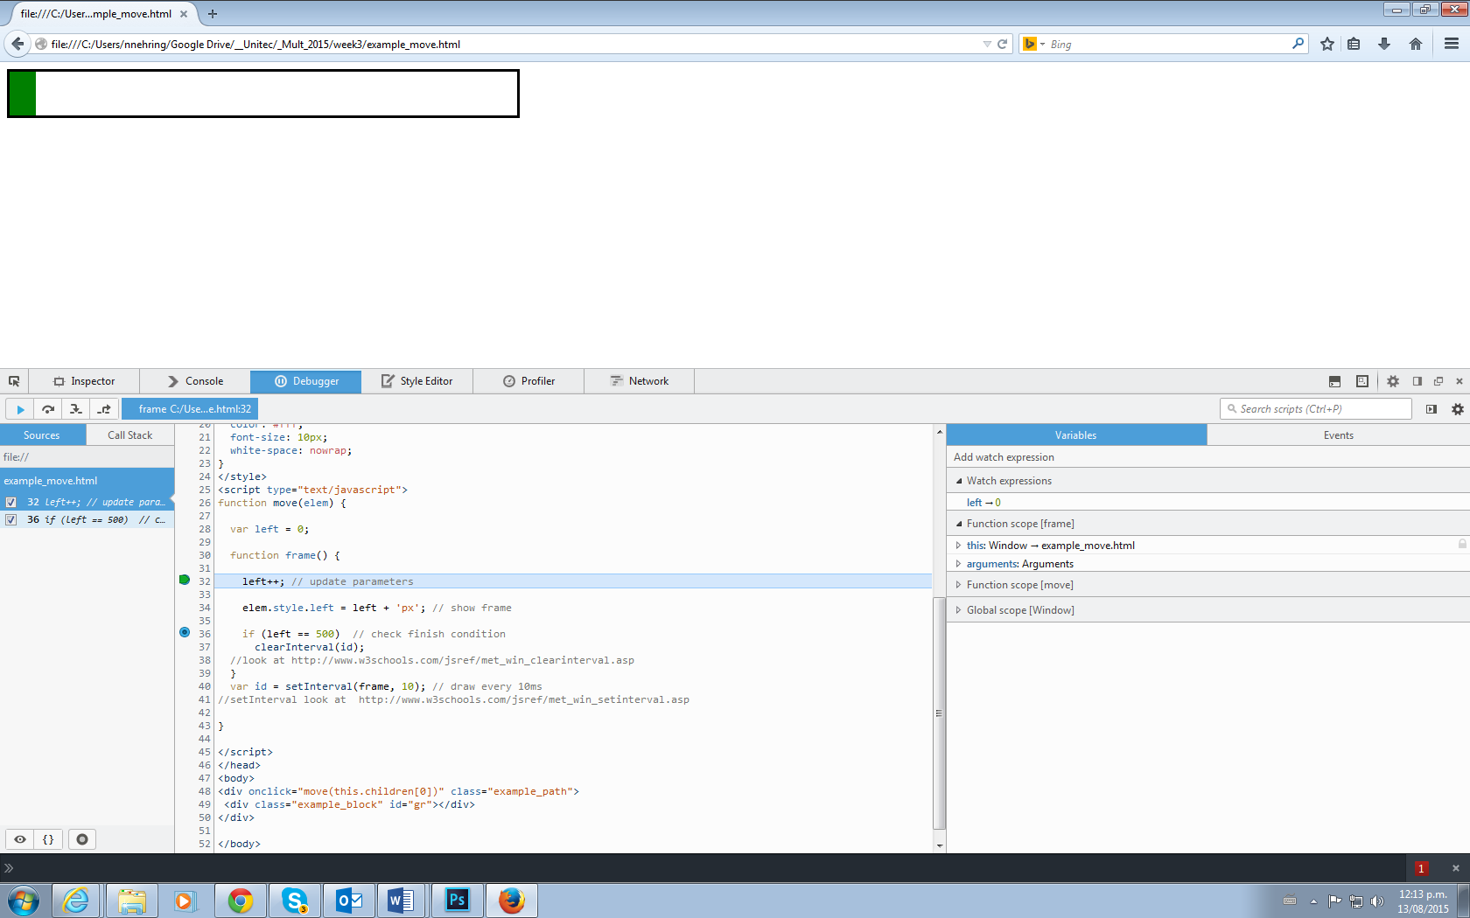

3 Please change code for **move** function

|  |  |
| --- | --- |
| if left <20 - stop | if left >300 - change direction |

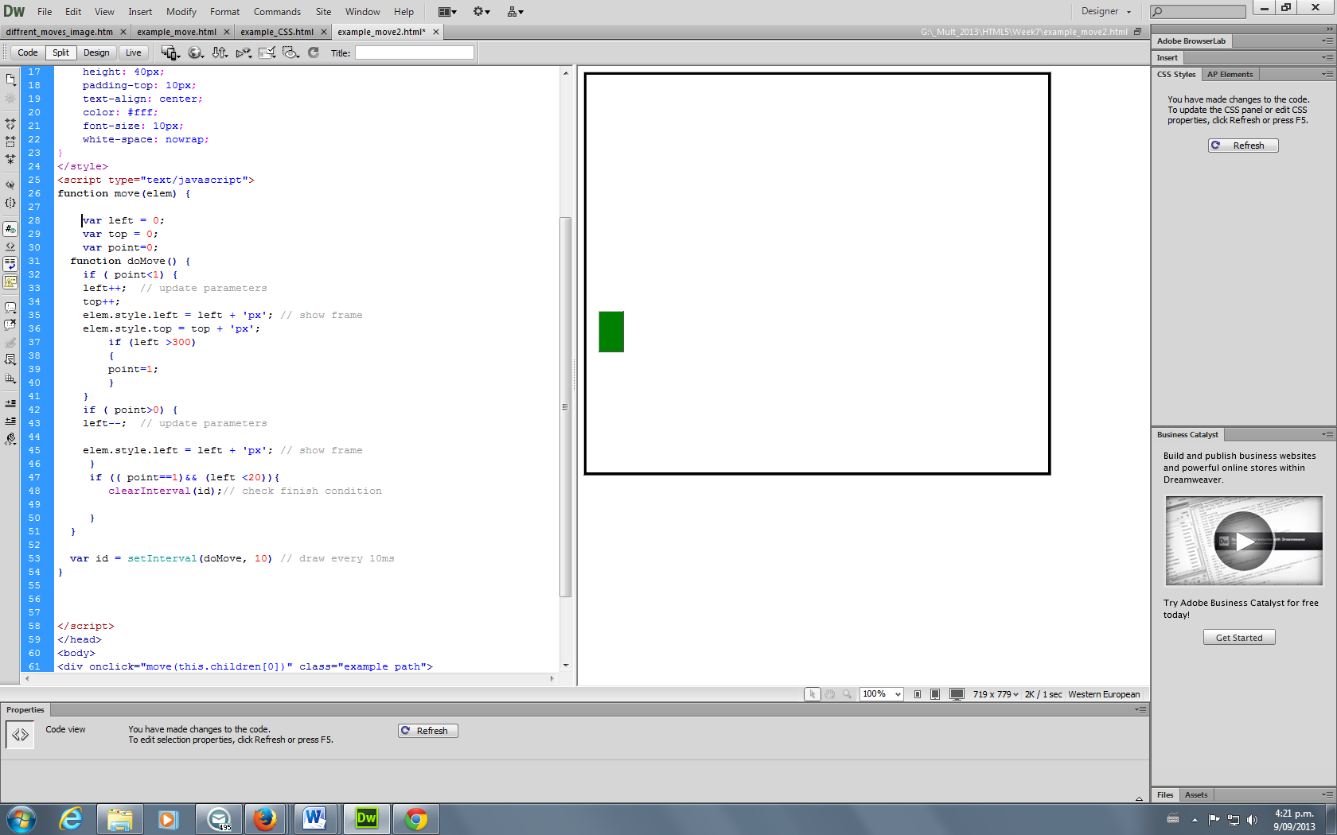

4 Change “style” for the green block put background – “butterfly.gif” and for the “example_path” put image “flowers-daizy.JPG (background-repeat:no-repeat;) 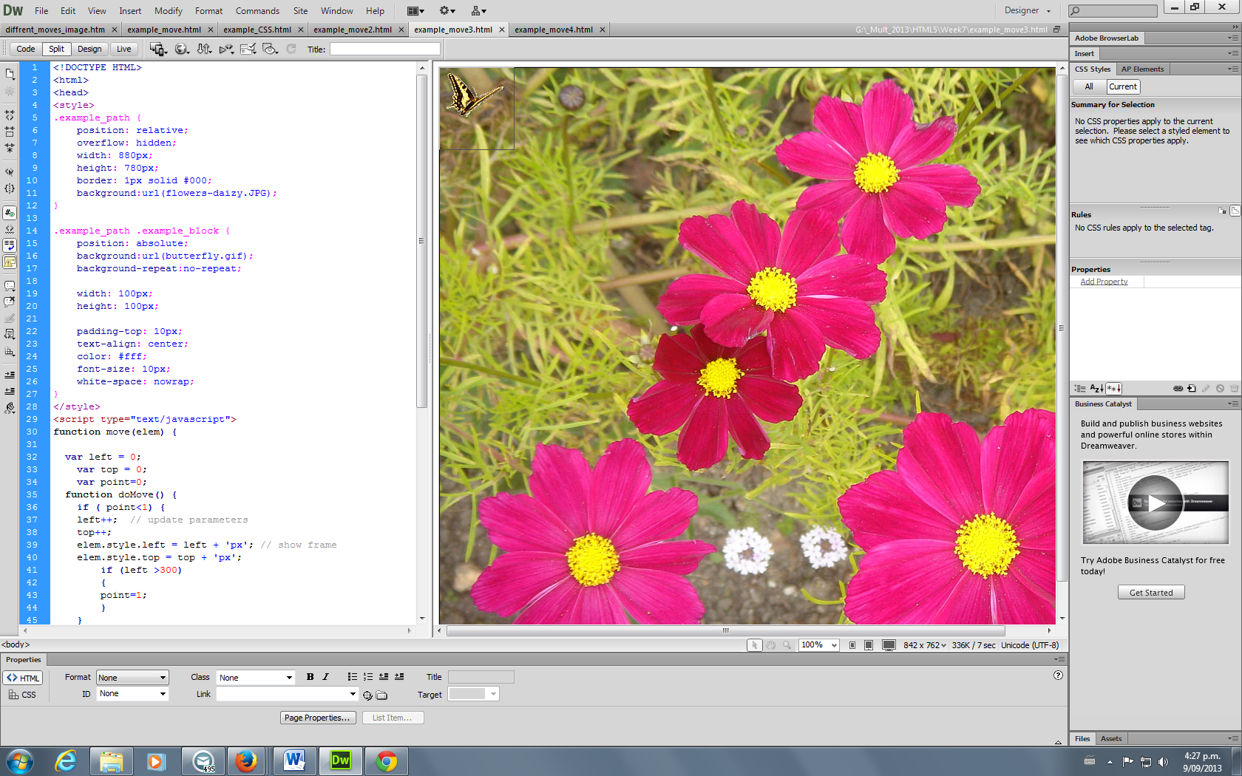

5 We add music – audio control ( inside <body> tag). Please test it.

<audio controls>

<source src="swan_lake.mp3" type="audio/mpeg">

Your browser does not support the audio element.

</audio>

We change our movement on more complex one:

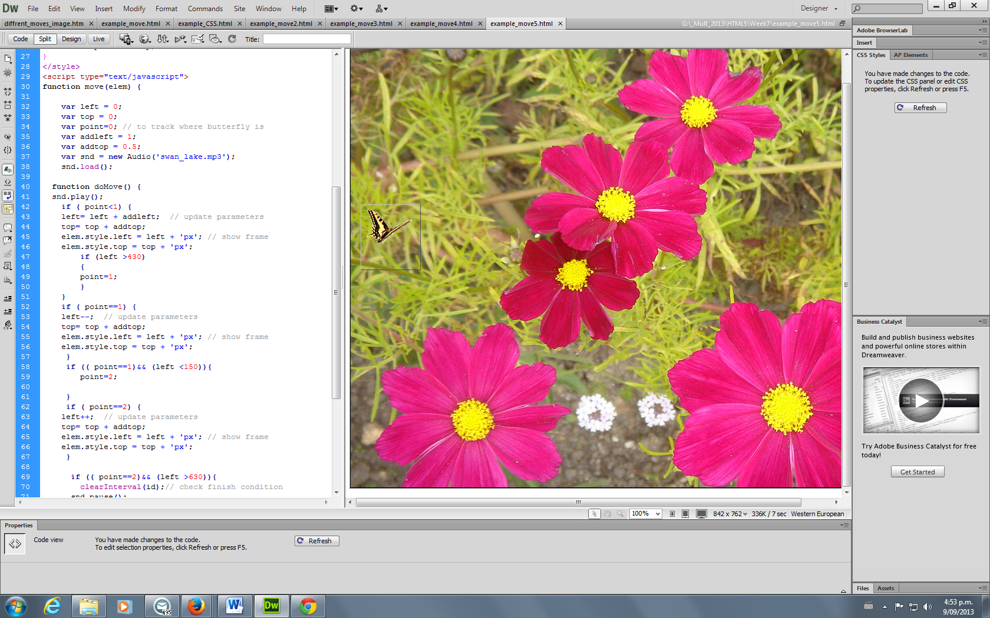

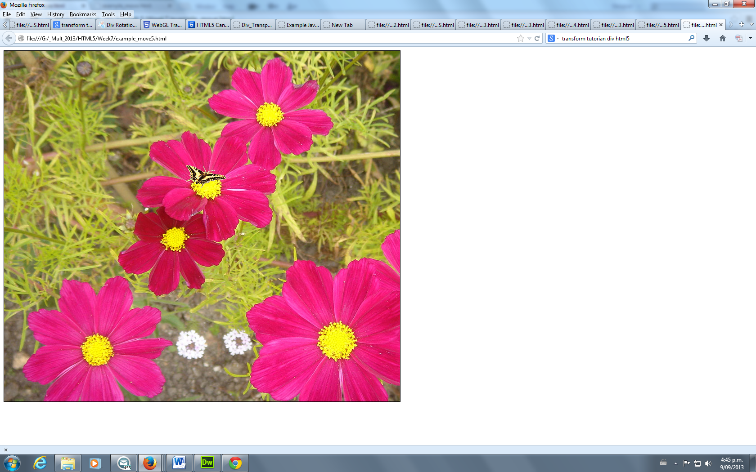

Point=2

Point=1

6 We want now to play music then “butterfly” start move.

Declare variable:

var snd = new Audio('swan_lake.mp3');

snd.load(); // you need to have it, that it will play on mobile device.

In function - function doMove() add line: snd.play();

And then movement stop add : snd.pause(); // to pause music.